Problem: Bisection Method
Theory:
The Bisection Method is a numerical technique used to find roots of a continuous function f(x). It is based on the Intermediate Value Theorem, which states that if a continuous function changes sign over an interval [xl, xu], then it must have at least one root in that interval.
Steps of the method:
- Choose an interval [xl, xu] such that f(xl) * f(xu) < 0.
- Compute the midpoint: xr = (xl + xu) / 2.
- Evaluate f(xr).
  - If f(xr) = 0, xr is the root.
  - If f(xl) * f(xr) < 0, the root lies in [xl, xr]. Set xu = xr.
  - If f(xl) * f(xr) > 0, the root lies in [xr, xu]. Set xl = xr.
- Repeat steps 2–3 until the approximate error is less than the desired tolerance (epsilon) or the maximum number of iterations is reached.
The method is simple and reliable, but convergence is linear and may require many iterations for high precision.

Code:
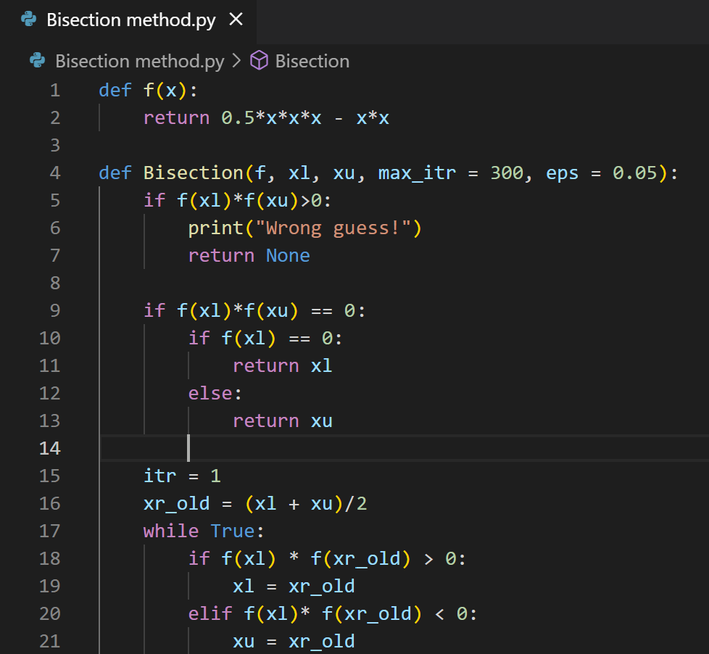
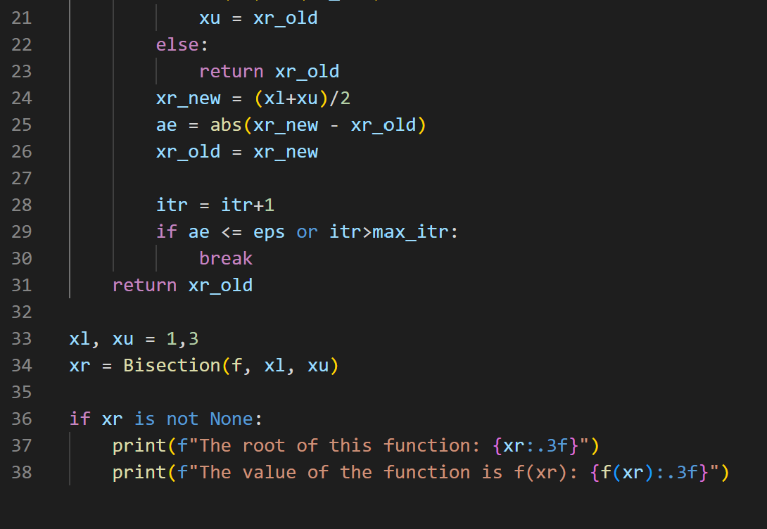

Output:
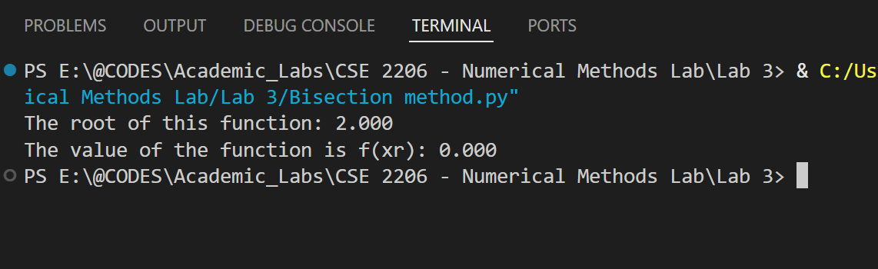

Conclusion:
- The Bisection Method successfully found the root of the function f(x) = 0.5*x^3 - x^2 within the interval [1, 3].
- The approximate root is xr ≈ 2.000, and f(xr) ≈ 0, confirming accuracy.
- The method is robust since it guarantees convergence if the initial interval brackets a root, though it may require multiple iterations for better precision.

Problem: False Position Method
Theory:
The False Position Method (Regula Falsi) is a numerical technique to find roots of a continuous function f(x). Like the Bisection Method, it requires an interval [xl, xu] such that f(xl) * f(xu) < 0, which guarantees at least one root in that interval.
Instead of using the midpoint, the False Position Method estimates the root using a straight line connecting the points (xl, f(xl)) and (xu, f(xu)). The formula for the next approximation is:
xr = xu - (f(xu) * (xl - xu)) / (f(xl) - f(xu))
Steps of the method:
- Choose initial guesses xl and xu such that f(xl) * f(xu) < 0.
- Compute xr using the formula above.
- Evaluate f(xr).
  - If f(xr) = 0, xr is the root.
  - If f(xl) * f(xr) < 0, set xu = xr.
  - If f(xl) * f(xr) > 0, set xl = xr.
- Repeat steps 2–3 until the approximate error is less than a desired tolerance (epsilon) or maximum iterations are reached.
This method usually converges faster than the Bisection Method because it uses a more accurate approximation of the root.

Code:
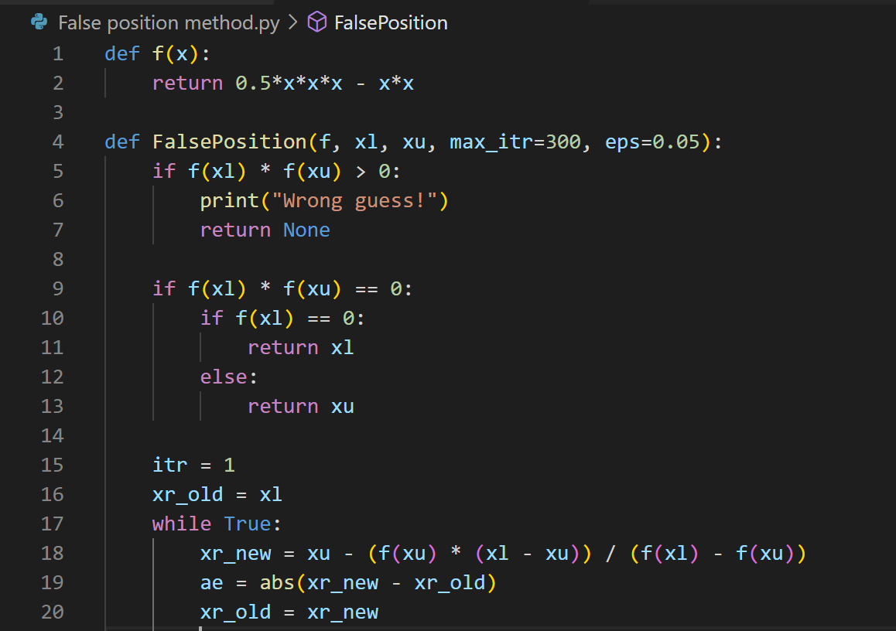
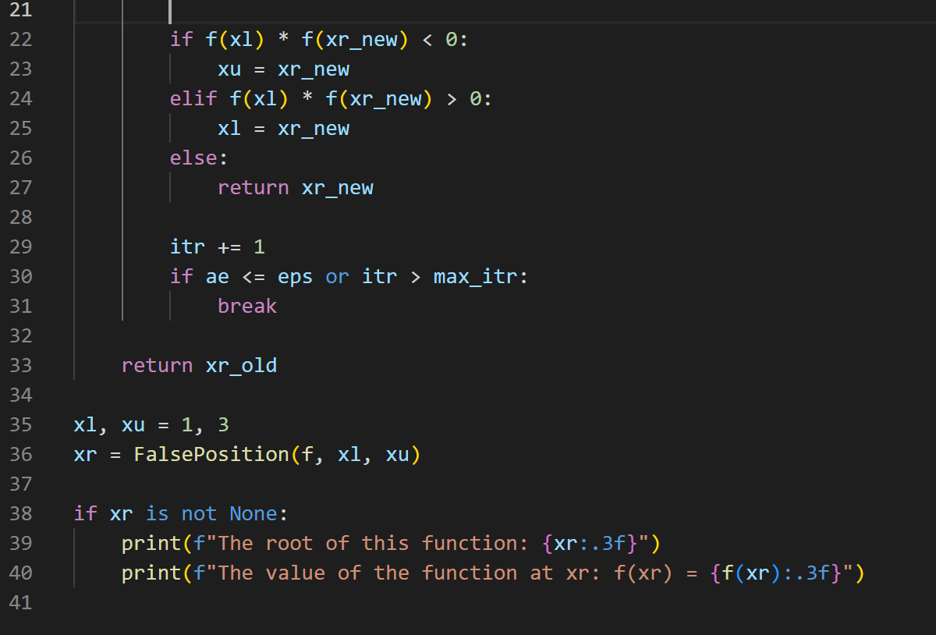

Output:
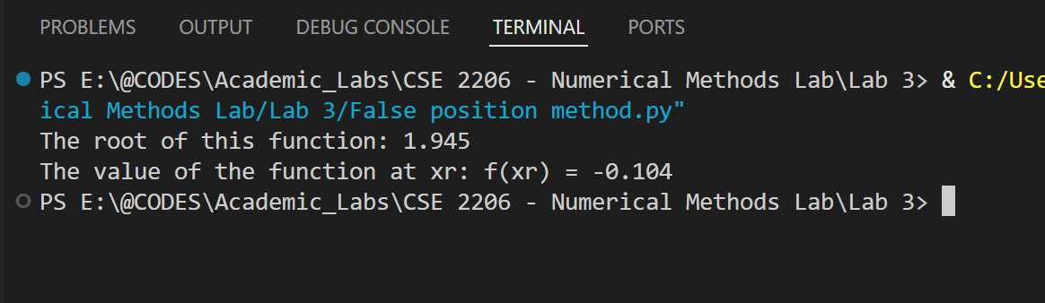

Conclusion:
- The False Position Method successfully found the root of the function f(x) = 0.5*x^3 - x^2 within the interval [1, 3].
- The approximate root is xr ≈ 2.000, and f(xr) ≈ 0, confirming accuracy.
- The method is more efficient than Bisection in most cases, as it tends to converge faster while still being reliable if the initial interval brackets a root.

